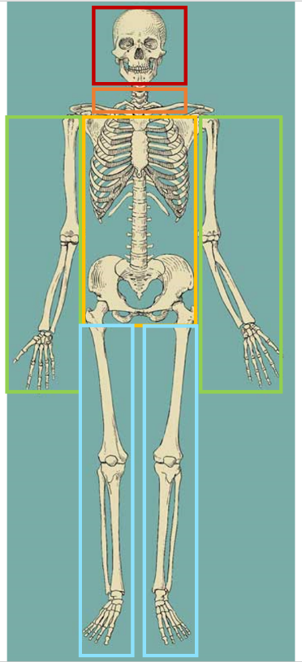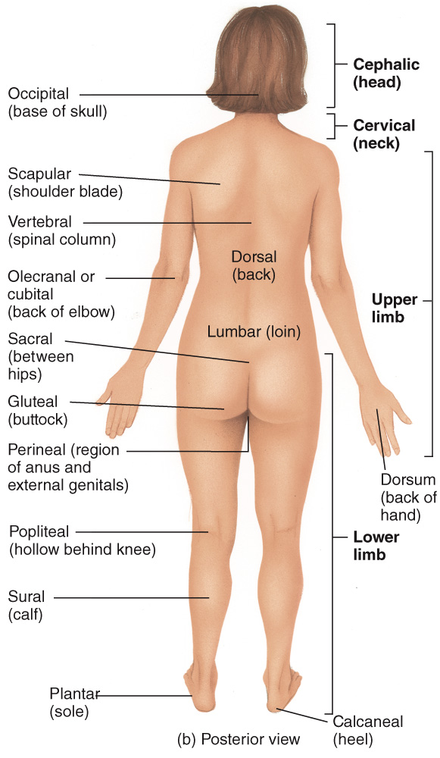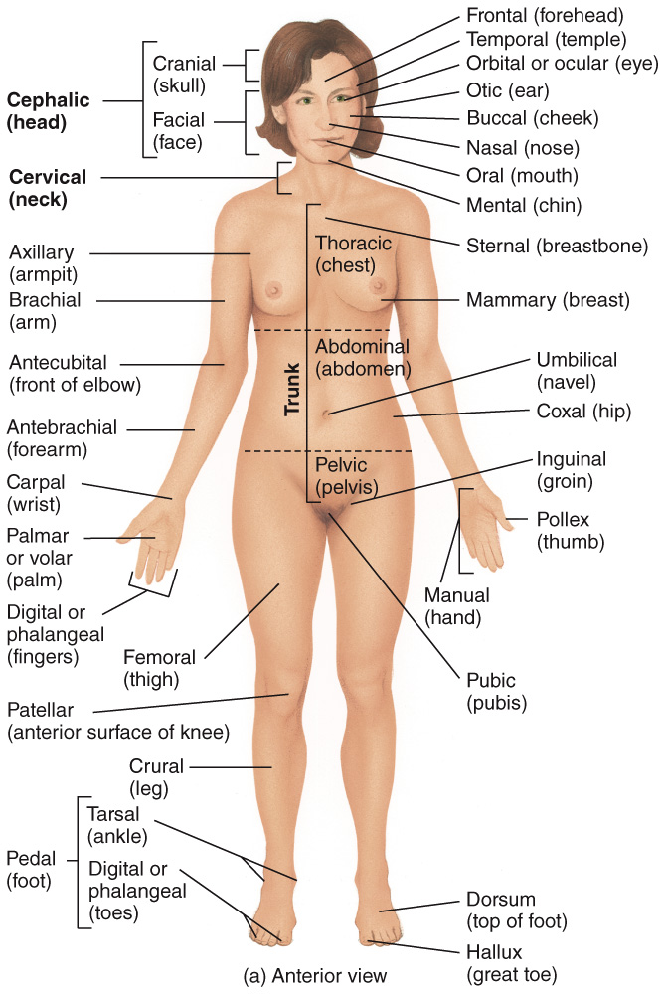**UNIT 1 STUDY GUIDE  
  
CH 1: Introduction to the Human Body**— **anatomical position:**   
 à head level  
 à eyes facing directly forward  
 à feet flat and directed forward  
 à palms facing forward   
  
— **regional names:** à head: consists of skull + face   
 à neck: supports the head and attaches it to the trunk  
 à trunk: consists of chest, abdomen, and pelvis  
 à upper limbs: attach to the trunk and consist of the shoulder,  
 armpit, arm, forearm, wrist, and hand  
 à lower limbs: attach to the trunk and consist of the buttock, thigh, leg, ankle, and foot  
  
— **anatomical names:**

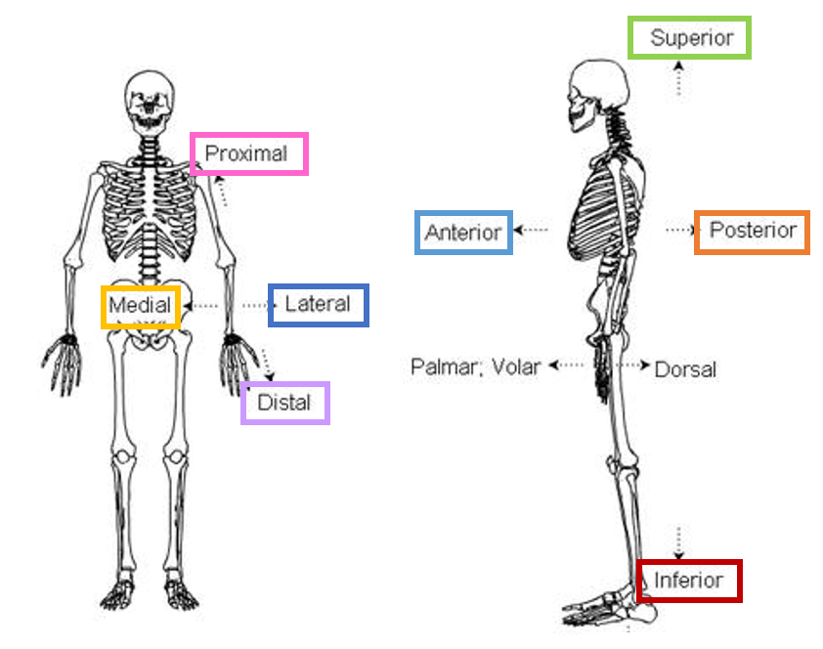— **directional terms:  
superior:** above, top, toward head  
**inferior:** below, bottom, away from head   
 **anterior:** toward the front  
**posterior:** toward the back  
  
**medial:** toward midline   
**lateral:** away from midline   
  
**proximal:** nearest the origin   
**distal:** farther away from the origin

**ipsilateral:** same side of the body   
**contralateral:** opposite side of the body

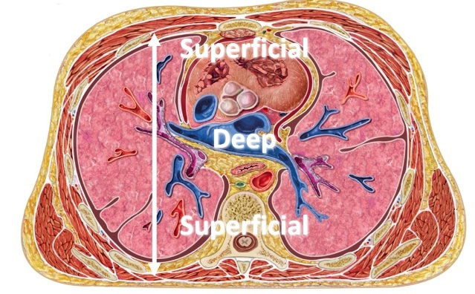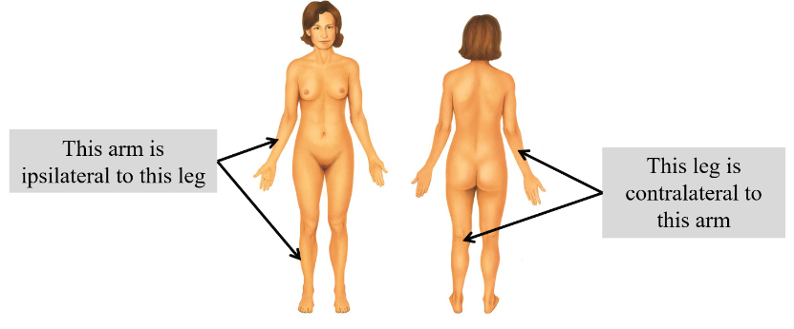**superficial:** toward the surface of the body   
**deep:** toward the core of the body

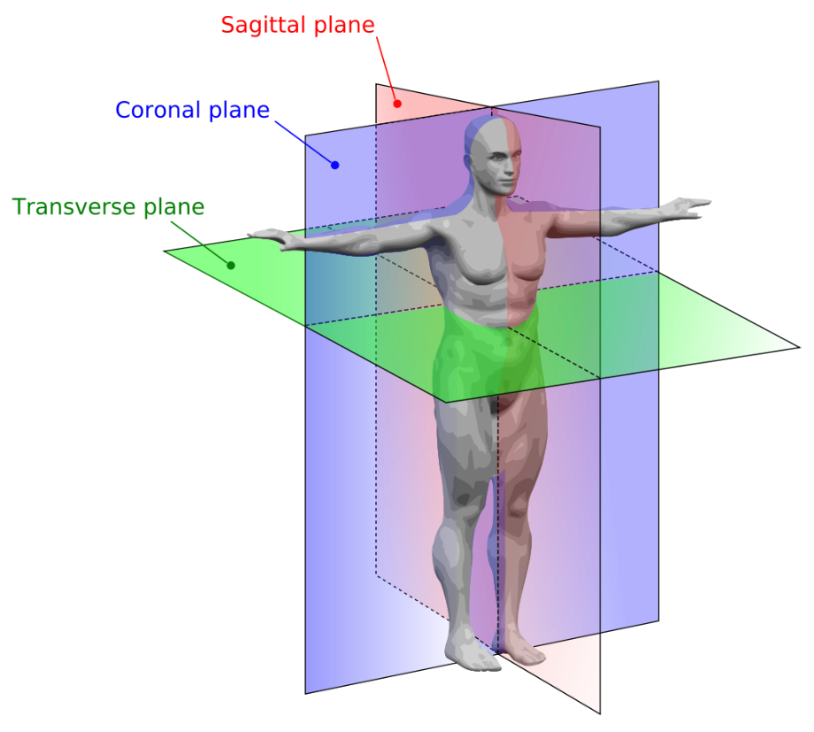  
  
— **body planes:**  
**sagittal:** vertical plane that divides the   
body or an organ into right and left parts  
  
**coronal (aka frontal):** divides the body or   
an organ into anterior (front) and posterior   
(back) sections  
  
**transverse (aka horizontal):** divides the  
body or an organ into superior (upper)   
and inferior (lower) portions

— **serous membranes:** slippery, double-layered membrane associated with body cavities that does not open directly to the exterior; it covers the viscera within the thoracic and abdominopelvic cavities and also lines the walls of the thorax and abdomen

[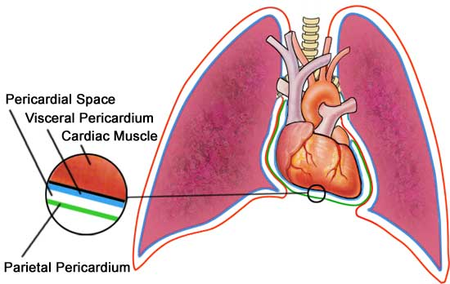](http://www.google.com/url?sa=i&rct=j&q=&esrc=s&frm=1&source=images&cd=&cad=rja&docid=w4JzV6l9d5pvMM&tbnid=6RBJnQCmUzfyHM:&ved=0CAUQjRw&url=http://www.virtualmedicalcentre.com/diseases/cardiac-tamponade/731&ei=SGMBUsy9GeKQyQHQ6oCIAw&psig=AFQjCNHpwrnnLyI1y5wAZsupSHeTyahKkA&ust=1375909054806449)

**pleura:** serous membrane of the pleural cavities  
visceral pleura: clings to surface of the lungs  
parietal pleura: lines the chest wall  
  
**pericardium:** serous membrane of the pericardial cavity  
visceral pericardium: covers the heart  
parietal pericardium: lines the chest wall   
  
**peritoneum:** serous membrane of the abdominal cavity  
visceral peritoneum: covers the abdominal viscera  
parietal peritoneum: lines the abdominal wall, covering the inferior surface of the diaphragm

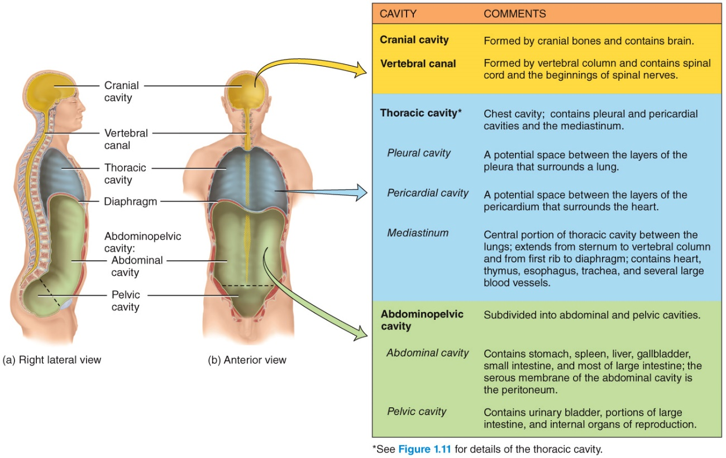— **body cavities:**  
boundary between thoracic/abdominopelvic cavity = diaphragm   
boundary between abdominal and pelvic cavity = pelvic inlet

— **body regions and quadrants:**

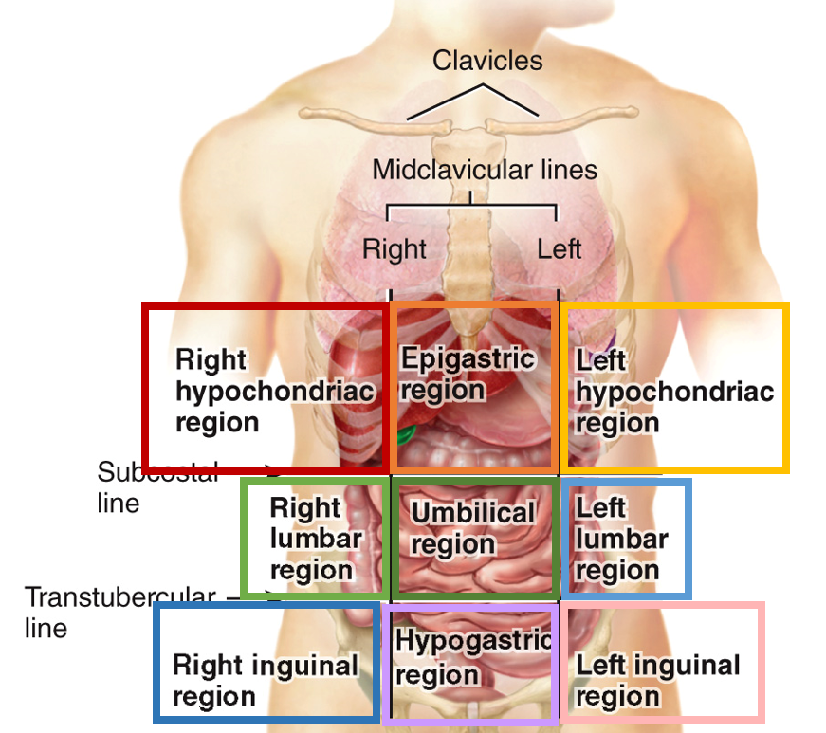

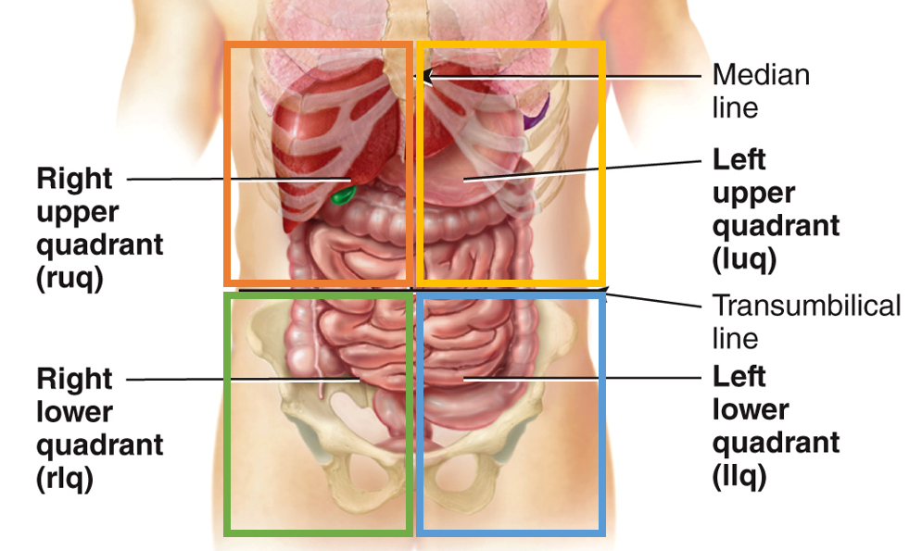

**CH 3: Cellular Level of Organization**— **cell:** the smallest structural and functional unit of an organism   
 à the human body has ~200 distinct cell types and contains 30-40 trillion cells   
 à most cells contain these 3 components:   
 [1] **plasma membrane:** cell’s flexible outer surface, separating internal/external  
 à comprised of a phospholipid bilayer with embedded proteins that serve many functions (ex. ion channels, transporters, cell markers   
 [2] **nucleus:** large organelle that houses most of the cell’s DNA  
 [3] **cytoplasm:** all the contents between the plasma membrane and nucleus   
 **cytosol:** the aqueous component of the cytoplasm of a cell, within which various organelles and particles are suspended

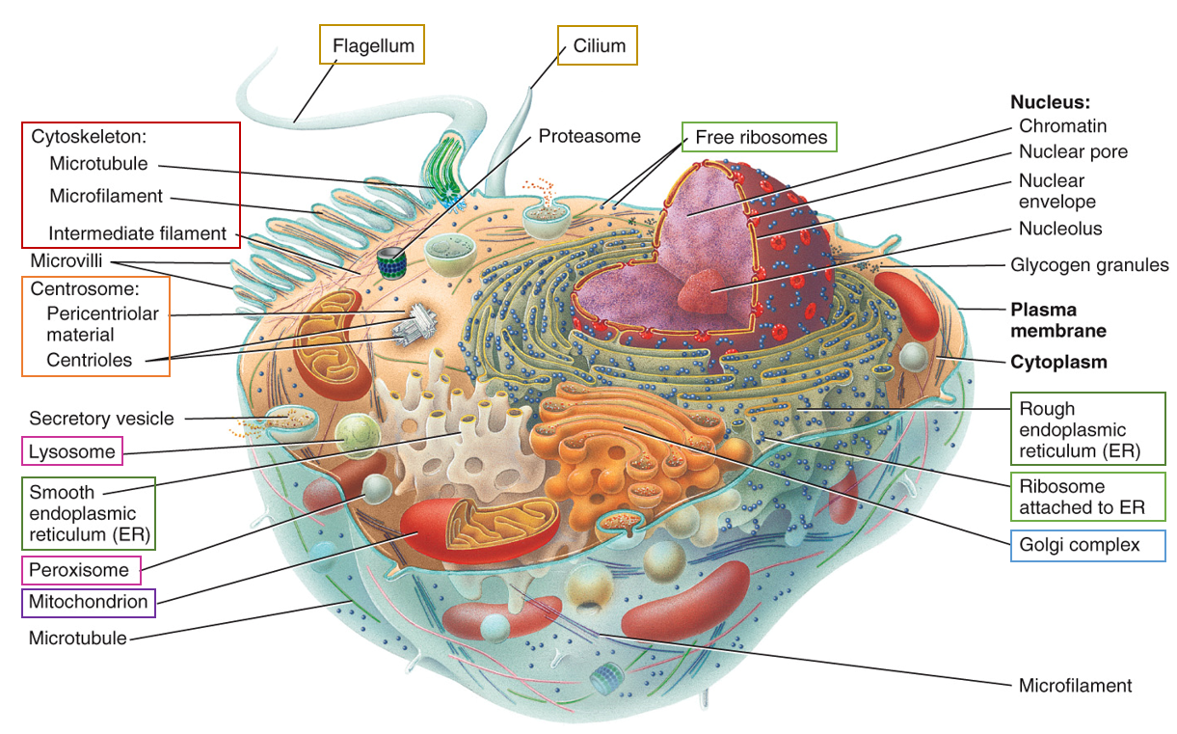

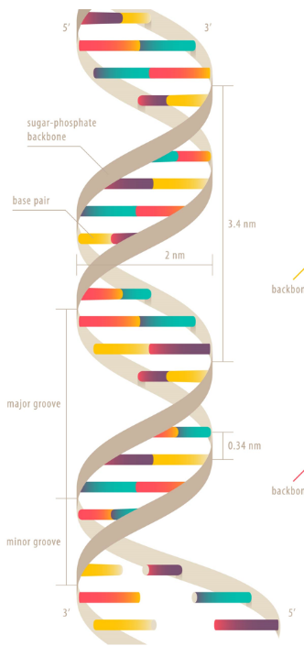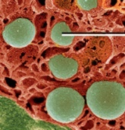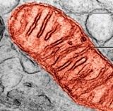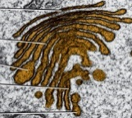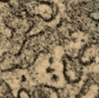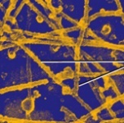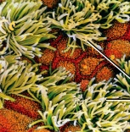— **cytoskeleton:** network of protein filaments that extends throughout the cytosol  
 function = maintain cell structure  
 participate in muscle contraction and cell division   
 à comprised of microfilaments, intermediate filaments, and microtubules   
  
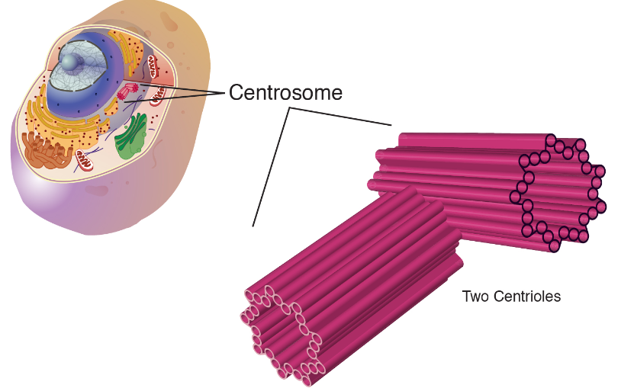— **centrosomes:** spherical structure adjacent to the nucleus, formed from a pair of centrioles at right angles to each other  
 function = maintain chromosome # during cell division   
  
— **cilia:** facilitate movement of objects across the apical surface of certain cells   
 example: found on cells in the fallopian tube (used to propel the egg)

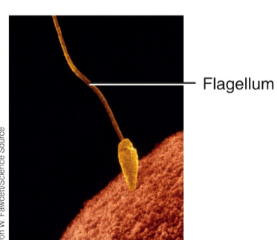— **flagella:** propel a cell forward   
 example: sperm   
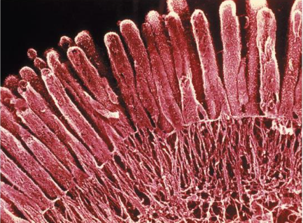— **microvilli:** TINY projections that increase cell surface area and facilitate absorption   
 example: epithelial lining of the small intestine

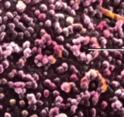— **ribosomes:** minute particles consisting of RNA and associated proteins  
 function = needed for protein synthesis   
 à can be freely floating in the cytoplasm or attached to the rough ER   
  
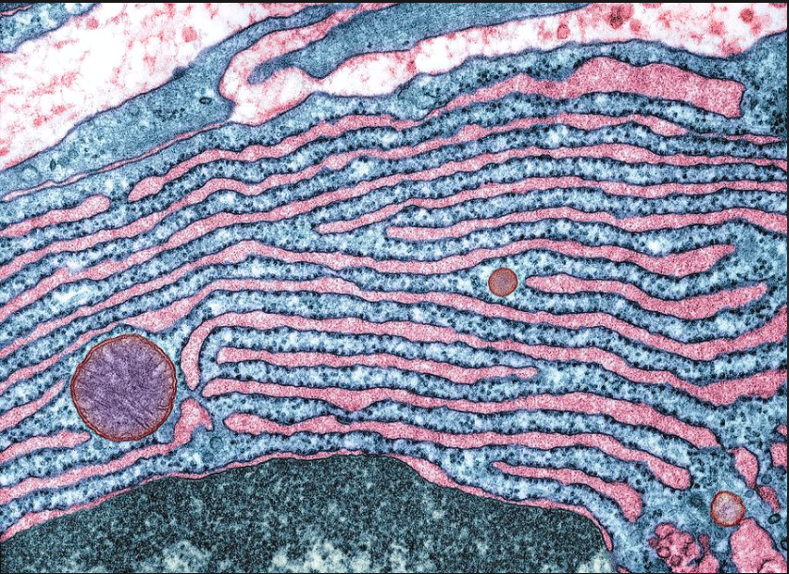— **rough endoplasmic reticulum:** walls appear rough due to attachment of ribosomes   
 function = synthesize, store, and transport proteins for secretion by the cell, incorporation into the plasma membrane, or to form lysosomes  
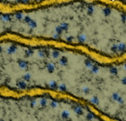— **smooth endoplasmic reticulum:** walls have smooth appearance (no ribosomes)   
 functions = synthesis, transport, storage of lipids   
 detoxification of drugs, alcohol, toxins  
  
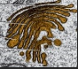— **golgi apparatus:** series of stacked cisternae  
 function = modify, sort, and package proteins and lipids received from the ER  
 “post office of the cell”   
  
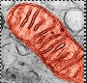— **mitochondria:** bean-shaped organelle with double membrane  
 function = produces ATP, “powerhouse of the cell”   
  
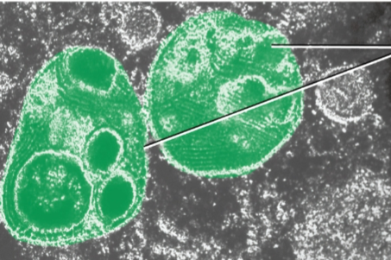— l**ysosomes:** a type of vesicle generated by the golgi that contains enzymes  
 function = digestion and removal of waste products  
  
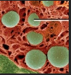— **nucleus:** houses the DNA  
à deoxyribonucleic acid (DNA): organic chemical that contains genetic  
 information and instructions for protein synthesis   
à chromosome: single molecule of DNA   
à gene: single segment of DNA

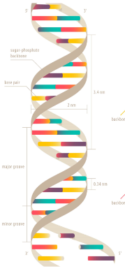

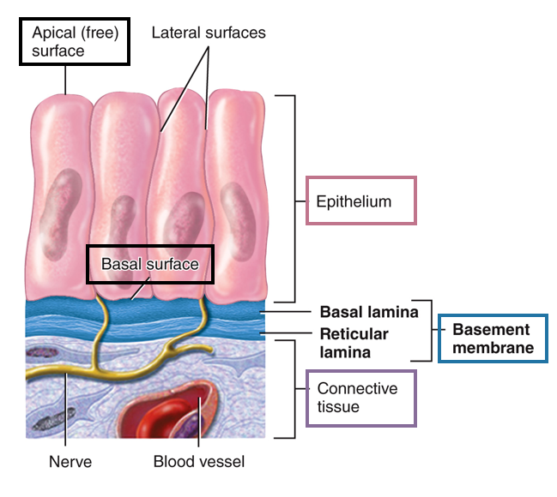**CH 4: Tissue Level of Organization**— **tissue:** group of similar cells and extracellular products that perform a common function; there are 4 types:   
[1] **epithelial:** covers body surfaces and lines hollow organs, body cavities, and ducts; forms glands; allows the body to interact with both its internal and external environment  
[2] **connective:** protects and supports the body and its organs; various types of connective tissues bind organs together, store energy reserves as fat, and help provide the body with immunity to disease-causing organisms  
[3] **muscle:** composed of cells specialized for contraction and generation of force; generates heat and warms the body  
[4] **nervous:** detects changes in a variety of conditions inside and outside the body; responds by generating electrical signals called action potentials that activate muscle contractions and glandular secretions

**[1] EPITHELIAL TISSUE**

**apical surface**: faces the lumen of a hollow  
organ (ex. stomach) or the external environment   
(ex. superficial layer of skin)   
**basal surface:** attaches epithelial tissue to the  
underlying basement membrane   
**basement membrane:** connects epithelial tissue to   
connecting tissue   
  
epithelial tissue characterized by   
[1] # of cell layers and [2] cell shape:

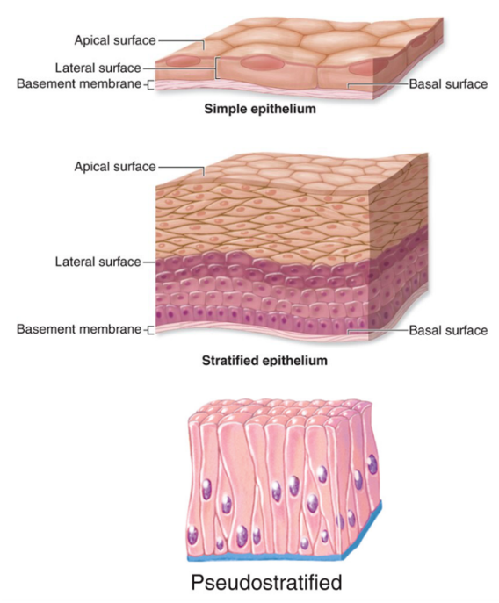**simple** = ONE layer   
**stratified** = MULTIPLE LAYERS   
**pseudo-stratified** = LOOKs stratified but is actually simple   
  
**squamous** = flat, round cells   
**cuboidal** = cuboid/square cells w/ centrally located nuclei   
**columnar** = tall cells w/ oblong nuclei located towards the basal surface

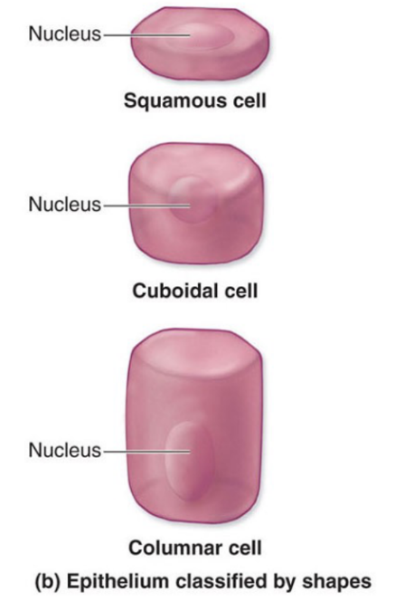

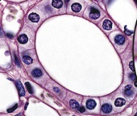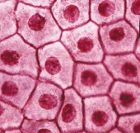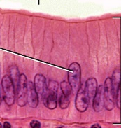— [1] **simple squamous:** single layer of squamous (flat) cells  
 location: lining of blood and lymph vessels (endothelium)   
 lining of serous membranes like the pleura (mesothelium)

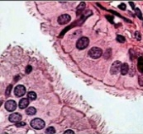— [2] **simple cuboidal:** single layer of cuboid (square) cells   
 location: found in small ducts (ex. urinary tubules of the kidney)  
  
— [3] **simple columnar (ciliated):** single layer of ciliated columnar (tall) cells   
 location: found in larger ducts (ex. the uterine/fallopian tubes)

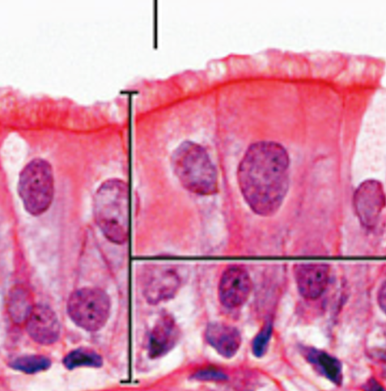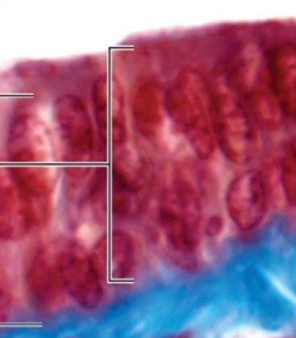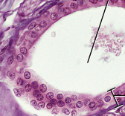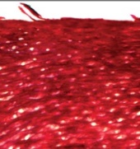— [4] **simple columnar (non-ciliated):** single layer of columnar (tall) cells   
 location: found in larger ducts (ex. the small intestine)   
  
---------------------------------------------------------------------------------------------------------------------  
— [5] **stratified squamous (keratinized):** multiple layers of squamous cells w/ keratin  
 location: form protective waterproof layer of the skin   
— [6] **stratified squamous (non-keratinized):** multiple layers of squamous cells   
 location: found in hollow organs with exposure to environment (ex. cheeks, vagina)   
**I will never ask you to visually identify the difference between keratinized vs. non-keratinized**  
  
— [7] **stratified cuboidal:** multiple layers of cuboid cells   
 location: found in ducts of many glands (ex. esophageal gland)   
  
— [8] **stratified columnar:** multiple layers of columnar cells   
 location: found in the male urethra and large ducts of salivary glands   
-------------------------------------------------------------------------------------------------------------------

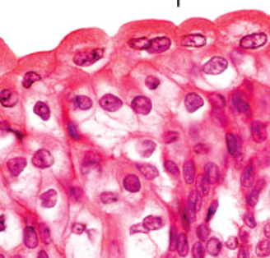— [9] **pseudo-stratified simple columnar:** appears stratified but is actually simple   
 location: found in some large ducts/tracts (ex. nasal cavity)   
  
— [10] **transitional:** cell shape varies too strongly or layering can change  
 location: urinary bladder

— **glands:** specialized epithelial tissue that performs a secretory function  
 à **endocrine glands:** do not possess ducts and secrete directly into the interstitial fluid or to the bloodstream (ex. thyroid gland)   
 à **exocrine glands**: secrete their products into ducts   
merocrine = secrete continuously (ex. salivary glands)   
apocrine = secrete discontinuously (ex. mammary gland); secretion collects in the apical portion of the cell, which then buds off as a unit to release the secretion  
holocrine = all cells of the secretory portion of the gland collect secretion products in the cytosol and then rupture, producing a lipid-rich secretion (ex. sebaceous glands)

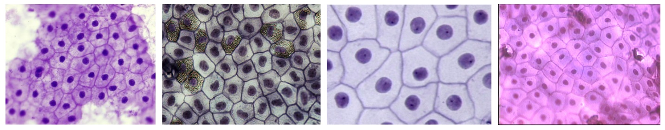**SIMPLE SQUAMOUS:**

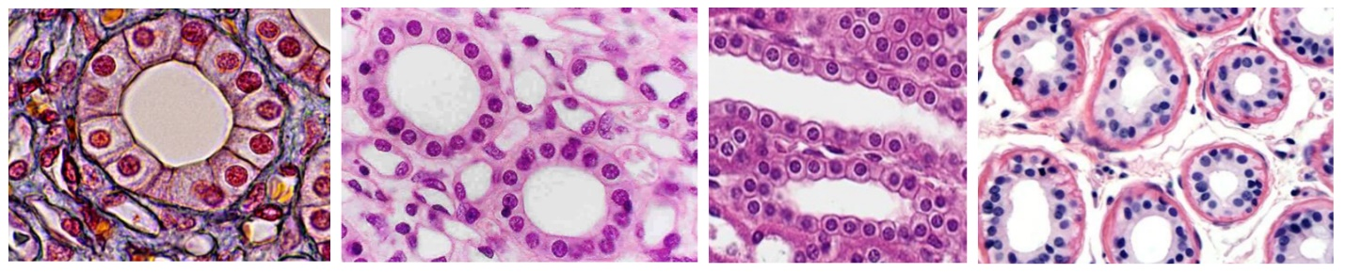**SIMPLE CUBOIDAL:**

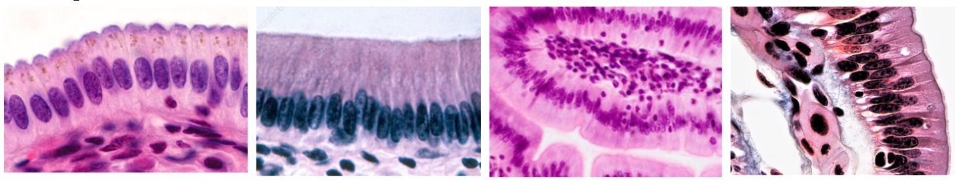 **SIMPLE COLUMNAR:**

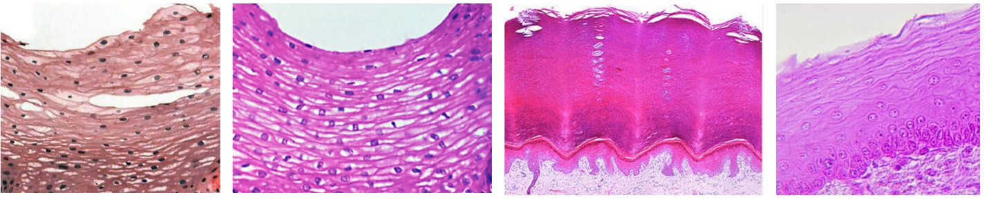 **STRATIFIED SQUAMOUS:**

**STRATIFIED CUBOIDAL:**

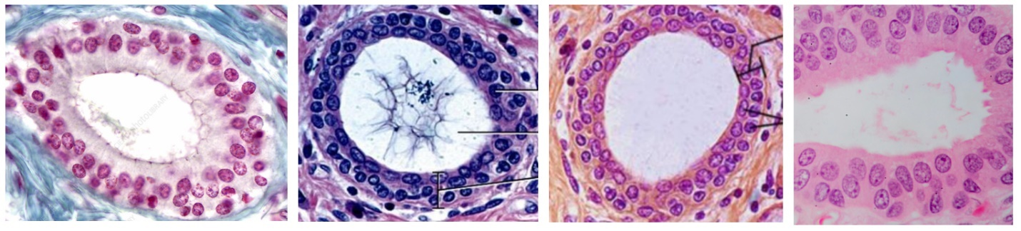

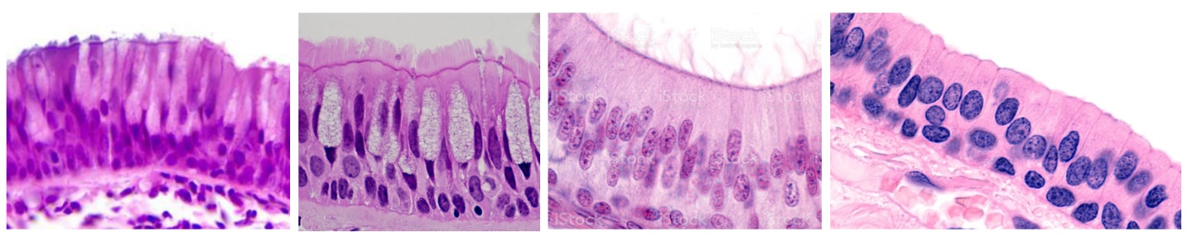**STRATIFIED COLUMNAR:**

**[2] CONNECTIVE TISSUE**

— **extracellular matrix:** three-dimensional network consisting of extracellular macromolecules and minerals, such as collagen, enzymes, glycoproteins and hydroxyapatite that provide structural and biochemical support to surrounding cells  
à can be comprised on protein fibers: **collagen**, **elastic**, **reticular**à **ground substance:** the component of the ECM that exists between cells and protein fibers; can range from jelly-like to liquid   
  
[1] Connective Tissue Proper – Loose   
— [1a] **areolar connective tissue:** the body’s “packing material”   
 location: in and around every body structure (ex. subcutaneous layer of skin)   
 function: strength, elasticity, support   
— [1b] **adipose tissue:** specialized for storage of triglycerides   
 location: wherever areolar connective tissue is located  
 function: reduces heat loss, serves as energy reserve, supports and protects organs  
— [1c] **reticular connective tissue:** network of reticular fibers and cells   
 location: stroma of certain organs, red bone marrow, basement membrane   
 function: forms stroma of organs, binds smooth muscle tissue cells, filters and removes worn-out red blood cells in spleen and microbes in lymph nodes  
 **AREOLAR CONNECTIVE TISSUE:**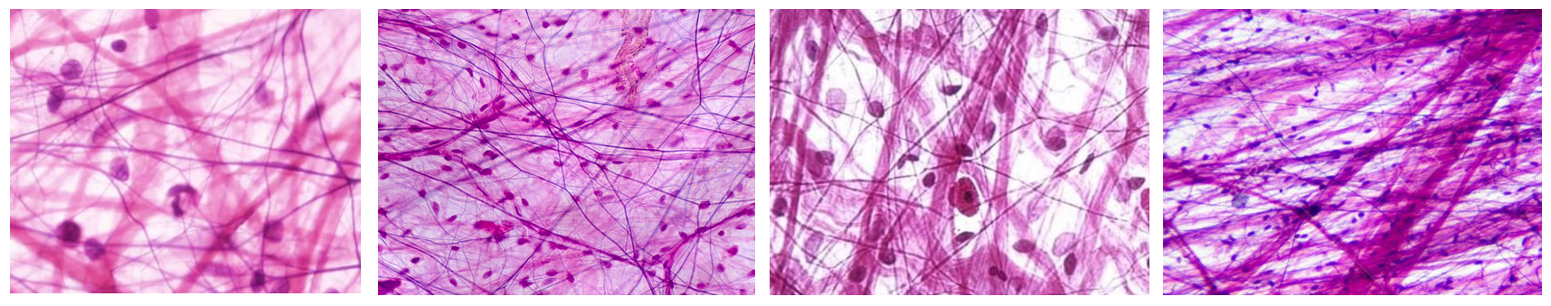

**ADIPOSE TISSUE:**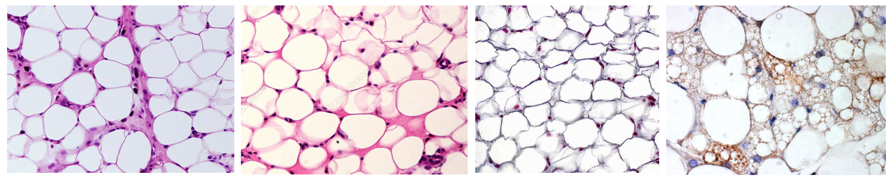

**RETICULAR CONNECTIVE TISSUE:**

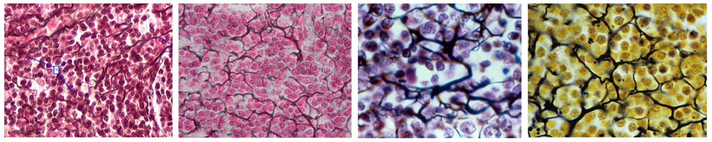

[1] Connective Tissue Proper – Dense   
— [1d] **dense regular connective tissue:** collagen fibers “regularly” arranged in bundles with interlaced fibroblasts  
 location: tendons, ligaments, aponeuroses   
 function: provides strong attachment between various structures  
— [1e] **dense irregular connective tissue:** collagen fibers “irregularly” arranged   
 location: fasciae, pericardium, periosteum of bone   
 function: provides tensile (pulling) strength in many directions   
— [1f] **elastic connective tissue:** contains elastic fibers with fibroblasts between them   
 location: lung tissue, elastic arteries, trachea, bronchial tubes, vocal cords  
 function: allows stretching of various organs   
  
**ELASTIC CONNECTIVE TISSUE:**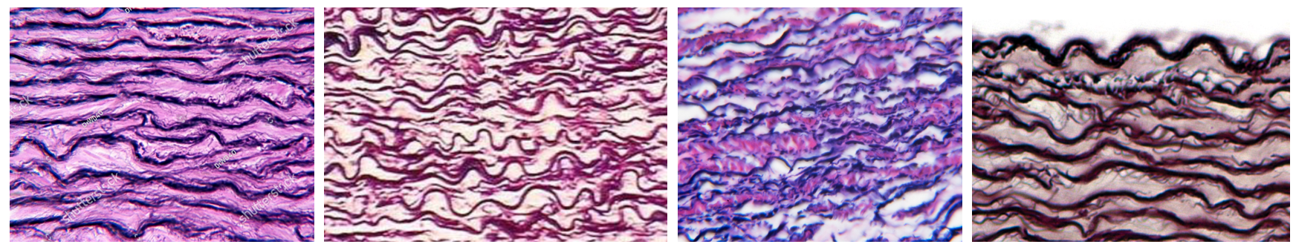

[2] Supporting Connective Tissue

— [2a] **hyaline cartilage:** jelly-like ground substance w/ prominent chondrocytes   
 location: ends of long bones, nose, trachea, bronchi, fetal skeleton  
 function: flexibility, support, provides smooth surfaces for movement at joints

— [2b] **fibrocartilage:** chondrocytes among thick bundles of collagen fibers  
 location: pubic symphysis, intervertebral discs, menisci   
 function: support and joining of structures together

— [2c] **elastic cartilage:** chondrocytes in thread-like network of elastic fibers   
 location: epiglottis, auricle, eustachian tubes   
 function: provides strength and elasticity, maintains shape of certain structures

— [2d] **bone:** composed of structures called osteons (compact bone) or trabeculae (spongy bone)  
 location: bone tissue   
 function: support, protection, storage of blood-forming tissue  
  
**HYALINE CARTILAGE:**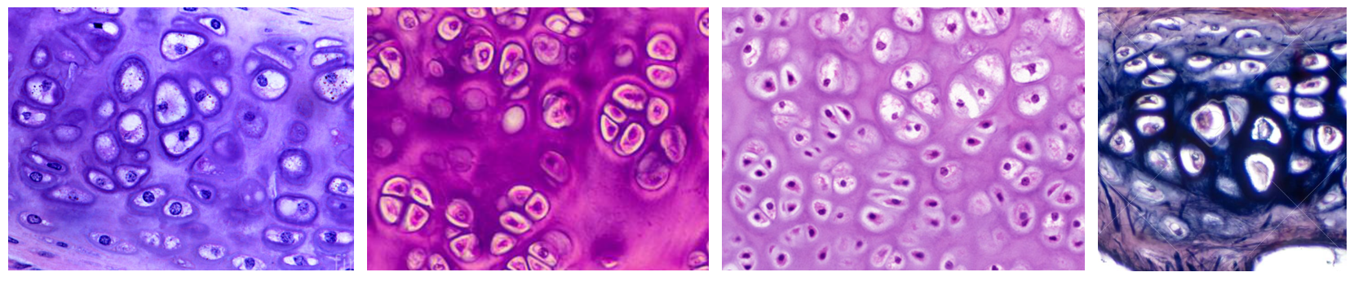

[3] Liquid Connective Tissue (blood and lymph)

— [3a] **blood:**   
 location: blood vessels   
 function: RBC = carry O2 and CO2 throughout the body   
 WBC = help the body fight against invading patogens   
 platelets = facilitate blood clotting   
**BLOOD:**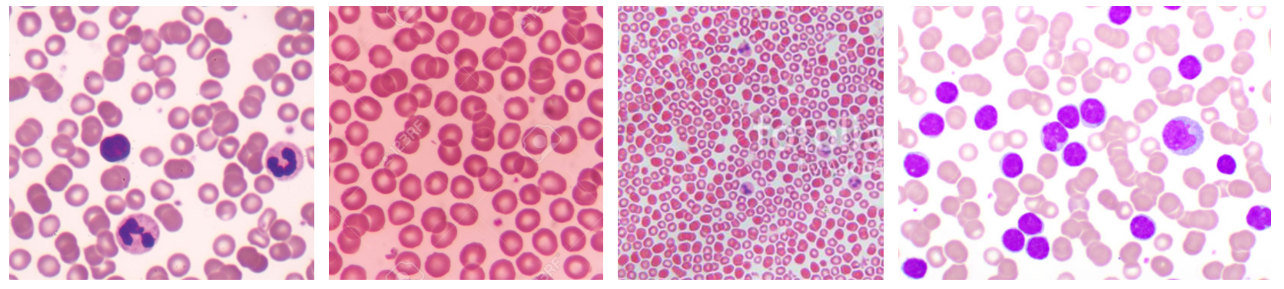  
  
— **cell junctions:** contact points between the plasma membranes of tissue cells  
[1] **tight junction:** web-like strands of transmembrane proteins fuse together the outer surfaces of adjacent plasma membranes to seal off passageways between adjacent cells   
[2] **adherens junction:** contain **plaque** = a dense layer of proteins on the inside of the plasma membrane that attaches both to membrane proteins and to microfilaments of the cytoskeleton)  
 à transmembrane glycoproteins called **cadherins** join the cells  
[3] **desmosomes:** contain plaque and have transmembrane glycoproteins (**cadherins**) that extend into the intercellular space between adjacent cell membranes and attach cells to one another   
[4] **hemidesmosomes:** resemble desmosomes but do not link adjacent cells  
 à hemidesmosomes anchor cells not to each other but to the basement membrane, connecting epithelial tissue to underlying connective tissue   
 à the transmembrane glycoproteins are called **integrins**[5] **gap junction:**   
 à membrane proteins are called connexins = form tiny fluid-filled tunnels called connexons that connect neighboring cells   
 à through connexins, ions and small molecules can diffuse from the cytosol of one cell to another

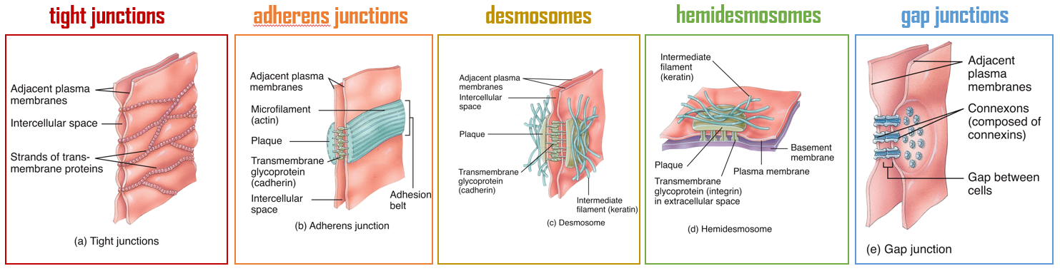

— **tissue changes:**[1] hypertrophy: increase in size of existing cells  
 ex. hypertrophic cardiomyopathy   
[2] hyperplasia: increase in the number of cells through cell division  
 ex. endometrial hyperplasia   
[3] atrophy: the shrinkage of a tissue through either decreased cell size or number  
 ex. neurodegeneration   
[4] metaplasia: occurs as a tissue changes from one type to another  
 ex. smoking-induced shift from columnar à squamous tissue   
[5] dysplasia (“bad form): occurs as a result of hyperplasia or metaplasia gone wrong  
 ex. development of tumor

**CH 5: Integumentary System**— **epidermis:** most superficial layer of the skin*epidermal cell types:*[1] **keratinocytes:** produce a protein called **keratin** = a tough, fibrous protein that helps protect the skin and underlying tissue from abrasion, heat, microbes, and chemicals  
[2] **melanocytes:** produce the pigment **melanin** = yellow-red or brown-black pigment that contributes to skin color and absorbs damaging UV light  
[3] intraepidermal macrophages: participate in immune response against microbes that invade the skin  
[4] tactile epithelial cells: located in the deepest layer of the epidermis where they contact the flattened process of a sensory neuron  
  
*layers:*[1] **stratum corneum:** consists of 25-30 layers of dead keratinocytes   
[2] **stratum lucidum:** consists of 4-6 layers of dead keratinocytes  
[3] **stratum granulosum:** consists of 3-5 layers of flattened keratinocytes   
undergoing apoptosis (programmed cell death)  
[4] **stratum spinosum:** thick layer of living keratinocytes, intraepidermal   
macrophages, and projections from melanocytes   
[5] **stratum basale:** consist of single row of cuboidal or columnar   
keratinocytes that serve as stem cells which continuously produce new   
keratinocytes to migrate superficially   
  
**keratinization:** process by which epithelial cells become filled with keratin  
protein filaments, die, and form tough, resistant structures in the skin   
and associated structures (like nails)  
  
— **dermis:** lies deep to the epidermis and is much thicker  *dermal layers:*[1] papillary region:   
à made of areolar connective tissue  
à surface area increased by **dermal papillae**, which push the layer into the epidermis  
à this creates epidermal ridges that give rise to fingerprints on thick skin (not found in thin skin)  
[2] reticular region:   
à made of dense irregular connective tissue  
à contains some adipose cells, hair follicles, nerves,   
sebaceous glands, and sudoriferous glands  
à attached to subcutaneous layer

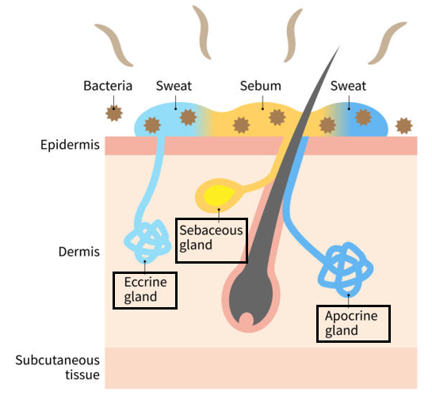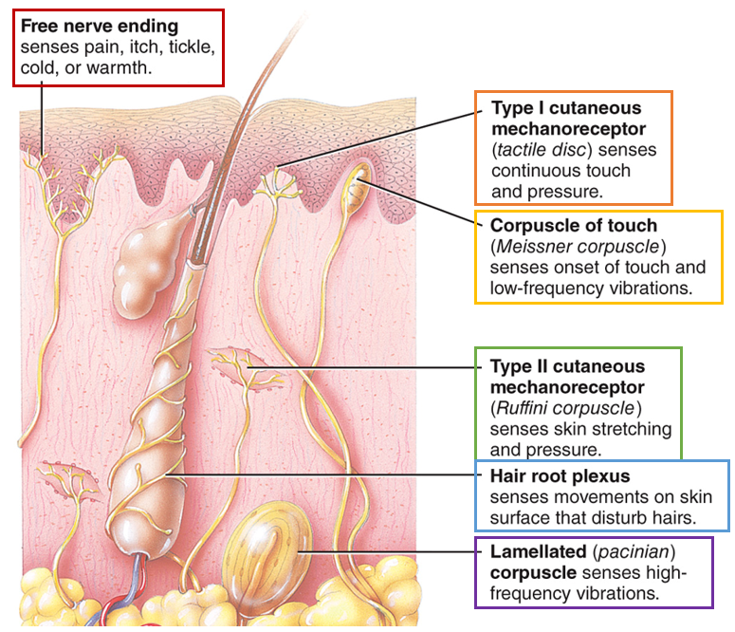*dermal cell types:*[1] free nerve endings: detect pain, itch, tickle,   
temperature  
[2] tactile discs: detect touch and pressure at   
skin surface  
[3] Meissner corpuscles: detect onset of touch   
and low frequency vibrations  
[4] Ruffini corpuscles: detect stretch and   
pressure  
[5] hair root plexus: detect movements on skin   
surface that disturb hairs  
[6] Pacinian corpuscles: detect high-frequency  
 vibration  
  
*accessory structures:*   
**sebaceous gland:** secrete a substance   
called sebuminto hair follicle  
à holocrine: all cells of the secretory portion  
of the gland collect secretion products in the   
cytosol and then rupture  
  
**sudoriferous gland:** secrete sweat into hair  
follicle or onto skin surface  
à merocrine: secrete continuously   
[1] eccrine: secrete sweat directly onto   
skin surface  
[2] apocrine: secrete sweat into hair follicle

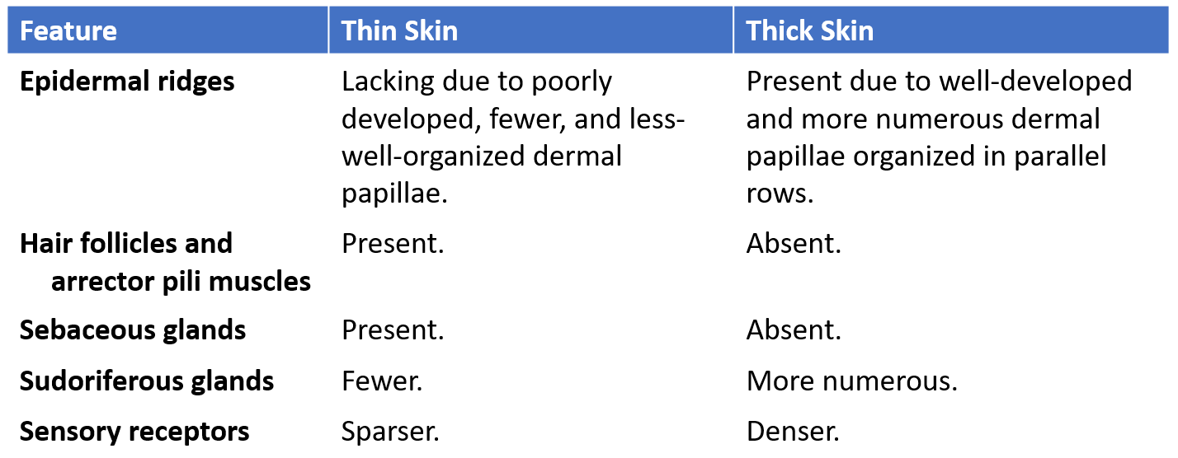

**SELECTED VIDEOS:   
  
Ch 1: Introduction**   
[Introduction to Anatomy & Physiology: Crash Course Anatomy & Physiology #1 - YouTube](https://www.youtube.com/watch?v=uBGl2BujkPQ&list=PL8dPuuaLjXtOAKed_MxxWBNaPno5h3Zs8&index=2)  
**Ch 3: Cells**[Eukaryopolis - The City of Animal Cells: Crash Course Biology #4 - YouTube](https://www.youtube.com/watch?v=cj8dDTHGJBY)  
**Ch 4: Tissues**   
[Tissues, Part 1: Crash Course A&P #2 - YouTube](https://www.youtube.com/watch?v=i5tR3csCWYo)  
[Tissues, Part 2 - Epithelial Tissue: Crash Course A&P #3 - YouTube](https://www.youtube.com/watch?v=lUe_RI_m-Vg)  
[Tissues, Part 3 - Connective Tissues: Crash Course A&P #4 - YouTube](https://www.youtube.com/watch?v=D-SzmURNBH0)  
[Tissues, Part 4 - Types of Connective Tissues: Crash Course A&P #5 - YouTube](https://www.youtube.com/watch?v=Jvtb0a2RXaY)  
**Ch 5: Integumentary System**[The Integumentary System, Part 1 - Skin Deep: Crash Course A&P #6 - YouTube](https://www.youtube.com/watch?v=Orumw-PyNjw)  
[The Integumentary System, Part 2 - Skin Deeper: Crash Course A&P #7 - YouTube](https://www.youtube.com/watch?v=EN-x-zXXVwQ)